**Pizza Sales Report**

1. KPIs
2. Total Revenue

SELECT SUM(total_price) as Total_Revenue from pizza_sales_total;

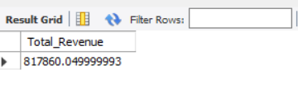

1. Average Order Value

SELECT SUM(total_price)/COUNT(DISTINCT(order_id)) as Average_order_value from pizza_sales_total;

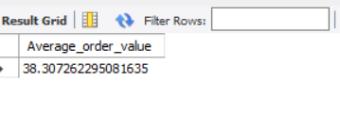

1. SELECT SUM(quantity) as Total_Pizza_sold FROM pizza_sales_total;

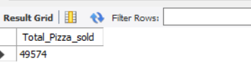

1. SELECT COUNT(DISTINCT(order_id)) as Total_Order FROM pizza_sales_total;

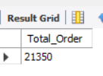

1. SELECT SUM(quantity)/COUNT(DISTINCT(order_id)) as Average_number_of_pizza_per_pizza FROM pizza_sales_total;

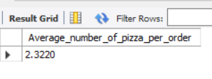

**CHARTS**

1. SELECT WEEKDAY(order_date) as order_day, COUNT(DISTINCT order_id)

FROM pizza_sales_total

GROUP BY WEEKDAY(order_date);

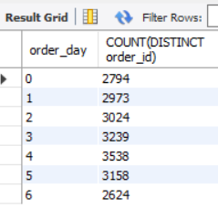

1. SELECT EXTRACT(HOUR from order_time) as order_hour, COUNT(DISTINCT order_id)

FROM pizza_sales_total

GROUP BY EXTRACT(HOUR from order_time)

ORDER BY order_hour;

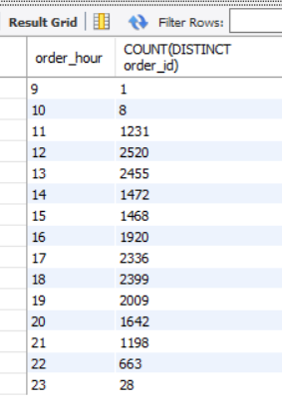

1. -- Percentage of pizza sales by category

SELECT pizza_category, round(sum(total_price),2) as total_sales, round(sum(total_price) * 100/

(SELECT sum(total_price) from pizza_sales_total where MONTH(order_date)=2),2) as Percentage_sales

FROM pizza_sales_total

where MONTH(order_date)=2

GROUP BY pizza_category

ORDER BY pizza_category;

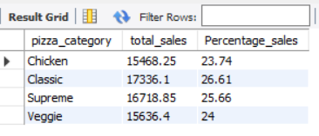

1. -- Percentage of pizza sales by size

SELECT pizza_size, round(sum(total_price),2) as total_sales, round(sum(total_price) * 100/

(SELECT sum(total_price) from pizza_sales_total WHERE EXTRACT(quarter from order_date) =1),2) as Percentage_sales

FROM pizza_sales_total

WHERE EXTRACT(quarter from order_date) =1

GROUP BY pizza_size

ORDER BY Percentage_sales DESC;

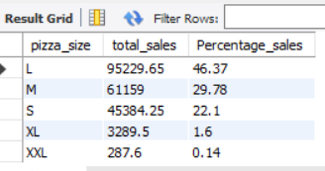

1. -- total pizza sold by category

SELECT pizza_category, sum(quantity) as total_pizza_sold

FROM pizza_sales_total

GROUP BY pizza_category

ORDER BY total_pizza_sold DESC;

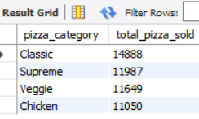

1. -- Best Sellers

SELECT pizza_name, sum(quantity) as best_sellers

FROM pizza_sales_total

GROUP BY pizza_name

ORDER BY best_sellers DESC

LIMIT 5;

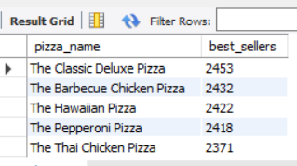

1. -- worst sellers

SELECT pizza_name, sum(quantity) as worst_sellers

FROM pizza_sales_total

GROUP BY pizza_name

ORDER BY worst_sellers

LIMIT 5;

